Online Examination Platform

# CSE 326: Information System Design Sessional

Mohammed Latif Siddiq, 1505069 | Nadia Anjum, 1505085

15-Feb-19

## Introduction

Online examination system is a platform where anyone can participate in examinations from anywhere. This software will ease the examination system as neither the teacher or the students must be present physically for attending the examination. This will save both time and cost. Moreover, students will be highly benefitted from the discussions and this will make quality education available to everyone.

## SYSTEM OVERVIEW

In this system, there are three types of user: student, teacher and admin.

Teacher can setup questions, declare examinations, monitoring registration system and publish blogs. Student can attend examinations, visit his/her rank list and compare them with countrywide students. He/she can also attend discussion with their teachers. An admin is the main controller of the system. He can control payment system, also can observe the discussion and maintains the quality of the system.

There are several subsystems in this platform.

Question, examination setup subsystem is one of the main subsystems. In this subsystem, teacher setup question, question papers and examination. And he can open registration for the examination.

In registration subsystem, teacher and student both interacts. Admin can also participate in this subsystem. Teacher open registration for the examination. Student pay the fee for the examination by any online money transferring medium, such as, Bkash, rocket, ipay etc. An admin should approve the payment and teacher can observe the registration.

In examination giving subsystem, students can participate in the examinations. An automated system analyzing solution and publish result. Students can see their result and rank. Teachers also can visit the rank list and result for any individual student of his institution.

In blog subsystem, teacher can post blog, edit and delete his own blog. All of our users can comment in any blog and share it in any social platform.

In this platform, there is another subsystem for login and signup. Teacher and institution have to be registered by this subsystem.

## Use case DIAGRAM

We presented two use case diagrams. One is for giving examination subsystem and another for blog platform.

In the following use case, teacher set up question, it is part of another subsystem. Student gives exam which depends on preparing questions. He/ she can give two types of exam, one is paid exam and another is practice exam. Teacher and student both can visit rank list and result.

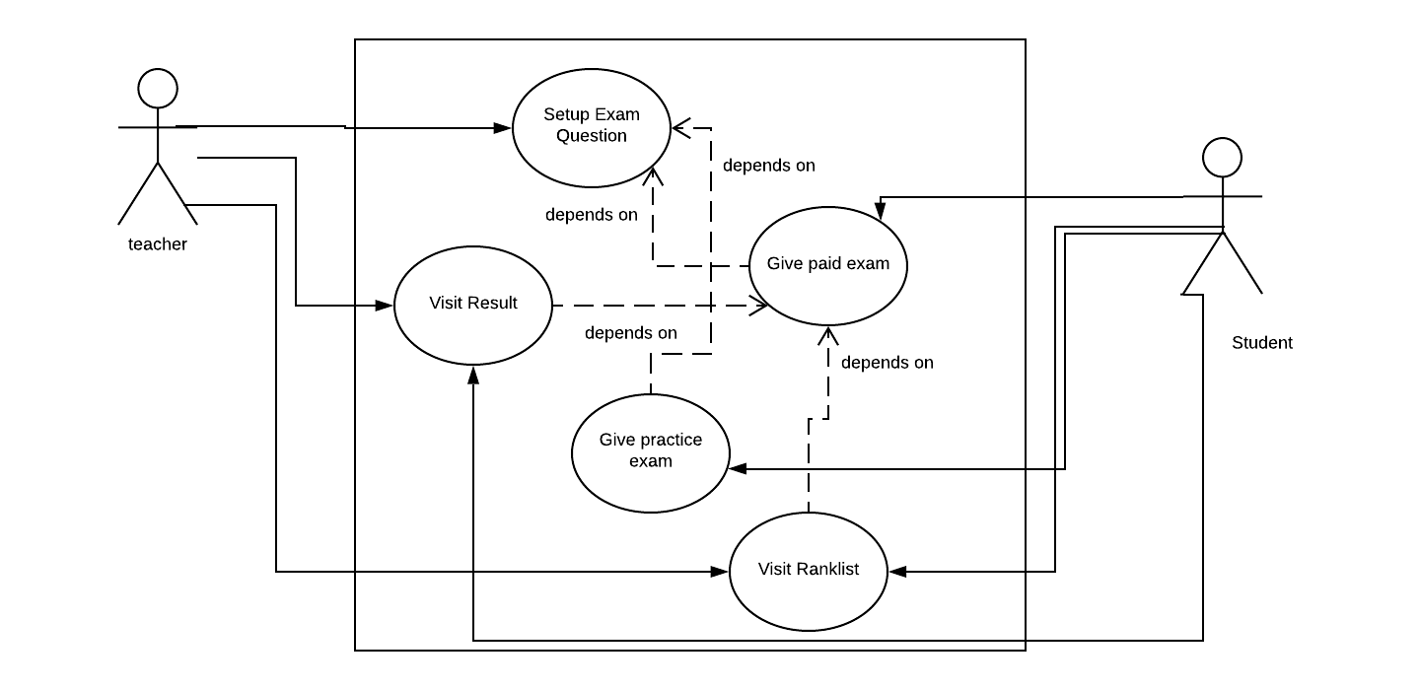

Figure: Giving examination subsystem

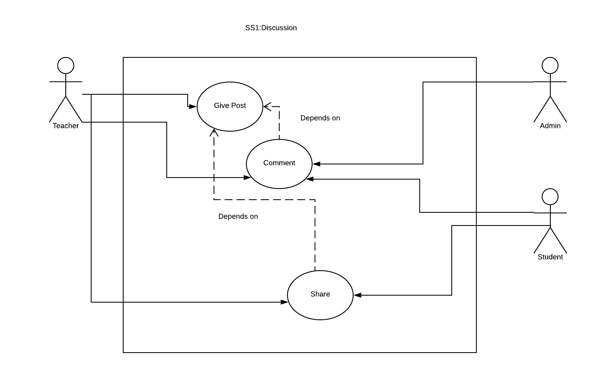Next, there is a use case diagram for blog system of our platform.

Figure: Blog subsystem

In this blog system, teacher can post any blog, where teacher, student and admin can comment. The blog can be shared to any social media platform by teacher and student.

## Entity relation diagram

In the following diagram, we can see the full entity relation diagram of our project:

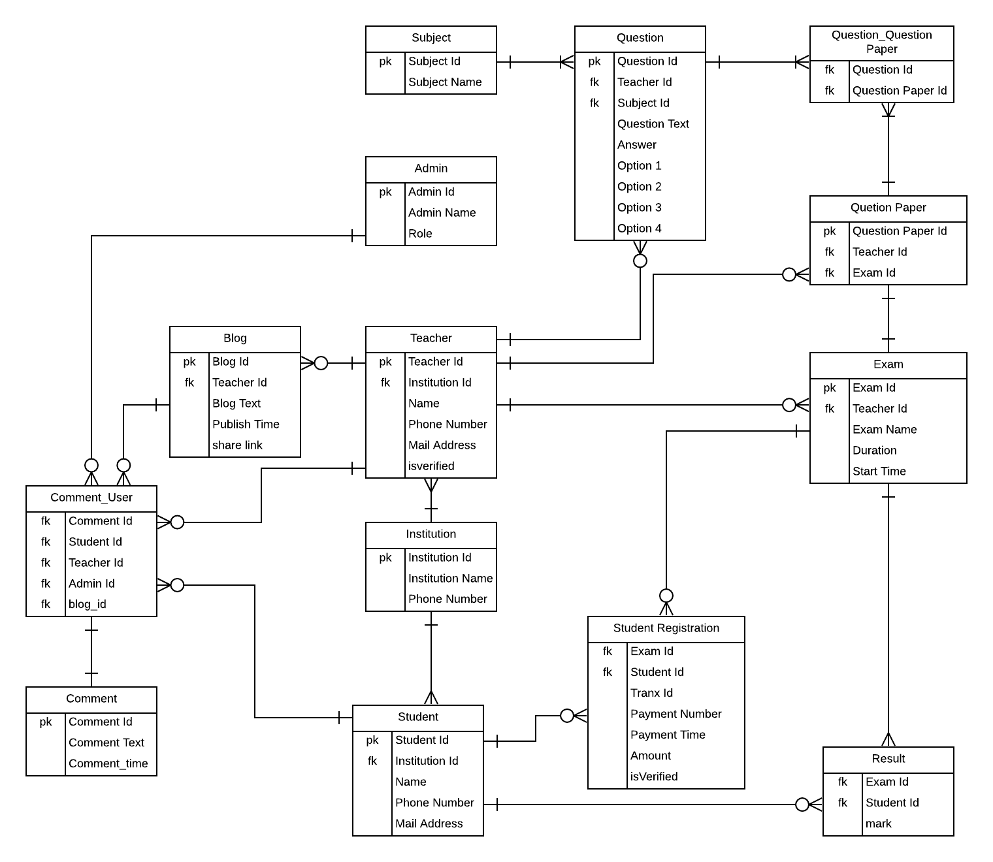

Figure: ERD of online examination platform

## Class DIARGRAM

We present two class diagrams, one is for examination setup subsystem and another for blog subsystem.

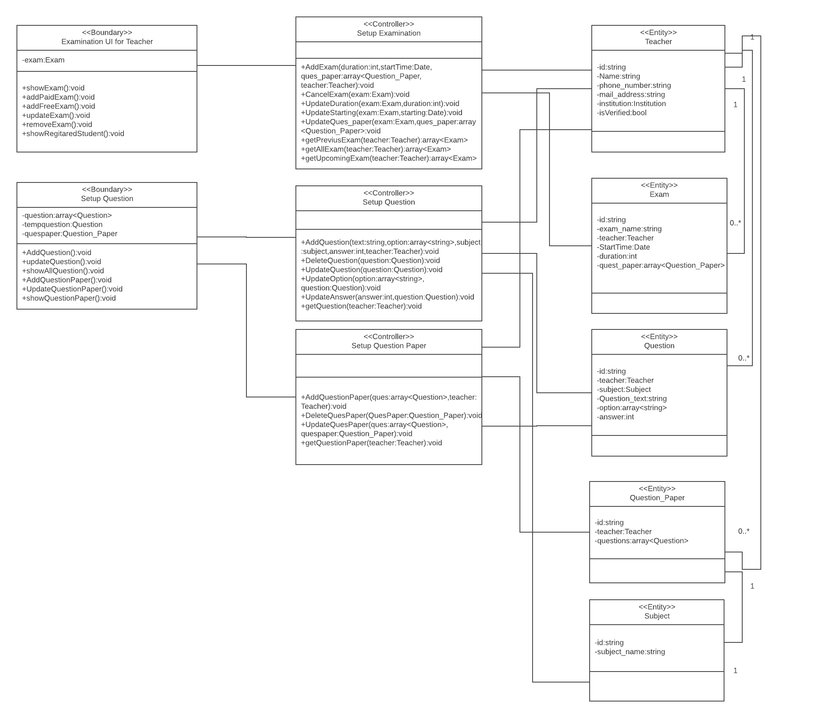This is the class diagram for examination setup subsystem:

Figure: Class diagram for examination setup subsystem

And this is the class diagram for blog subsystem:

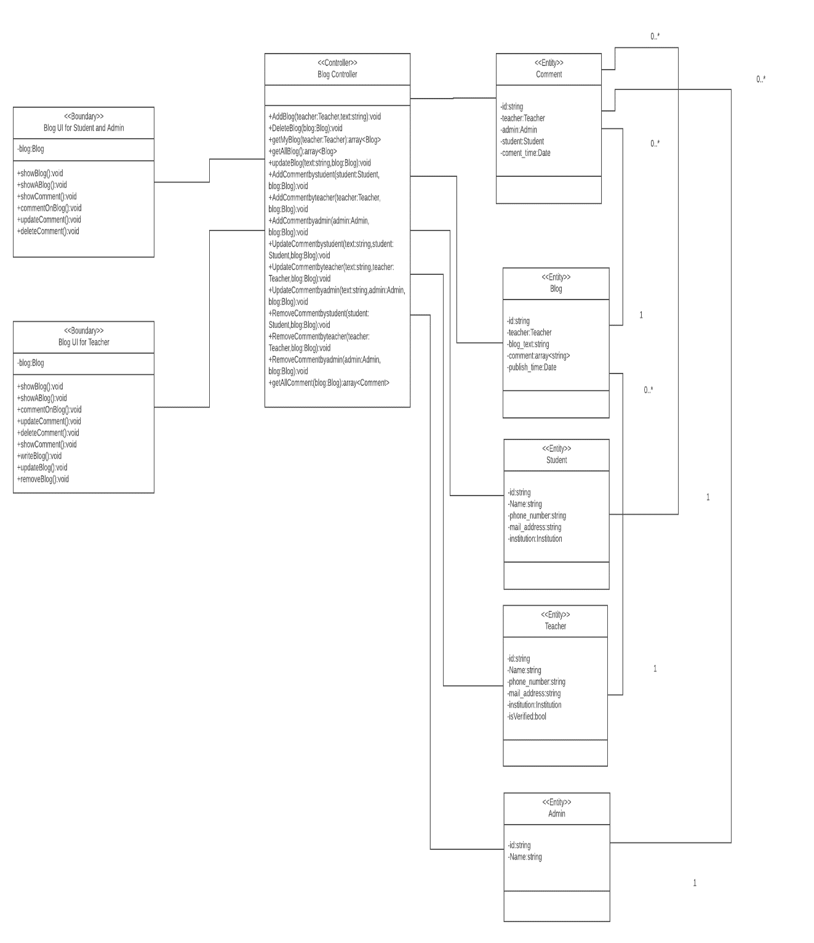

Figure: Class diagram for blog subsystem

## Sequence diagram

For the sessional, we present two sequence diagrams: one is for examination setup subsystem and another for blog subsystem.

In the following diagram, we can see the sequence diagram for examination setup subsystem:

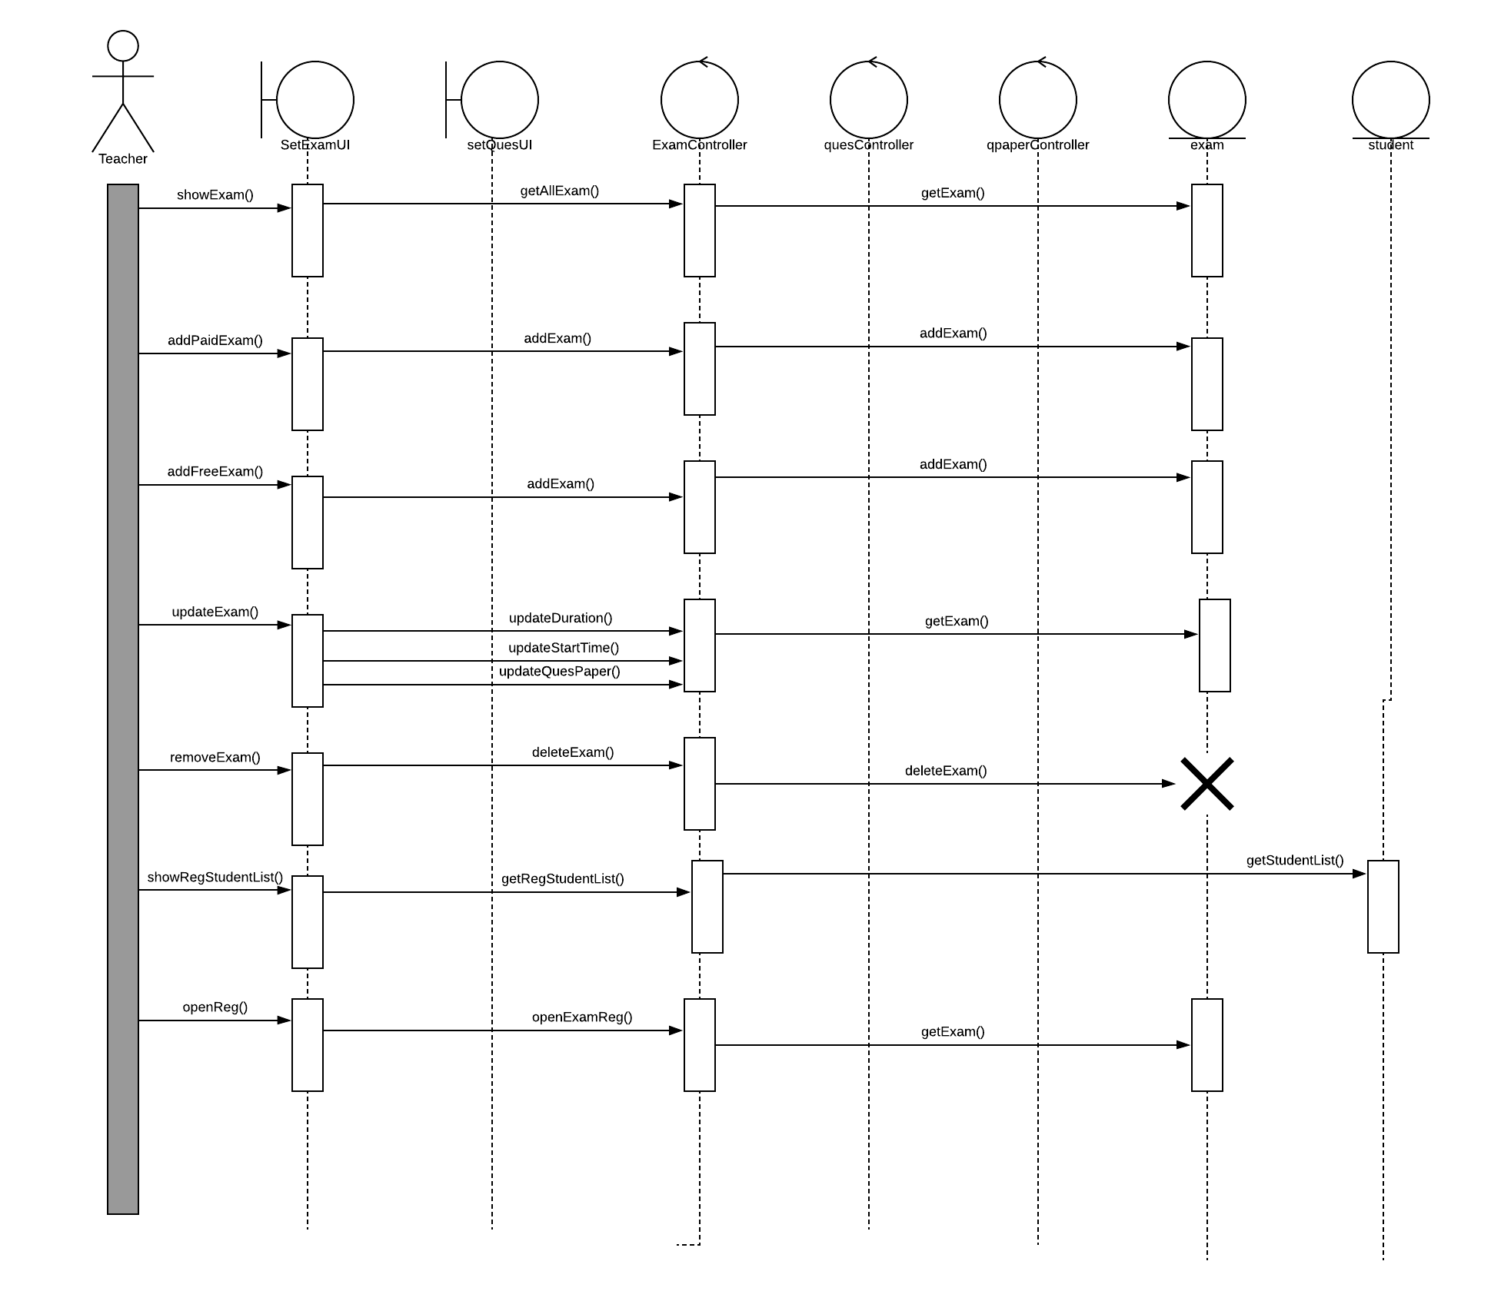

Figure: Sequence diagram for examination setup subsystem

And the following sequence diagram is for the blog subsystem:

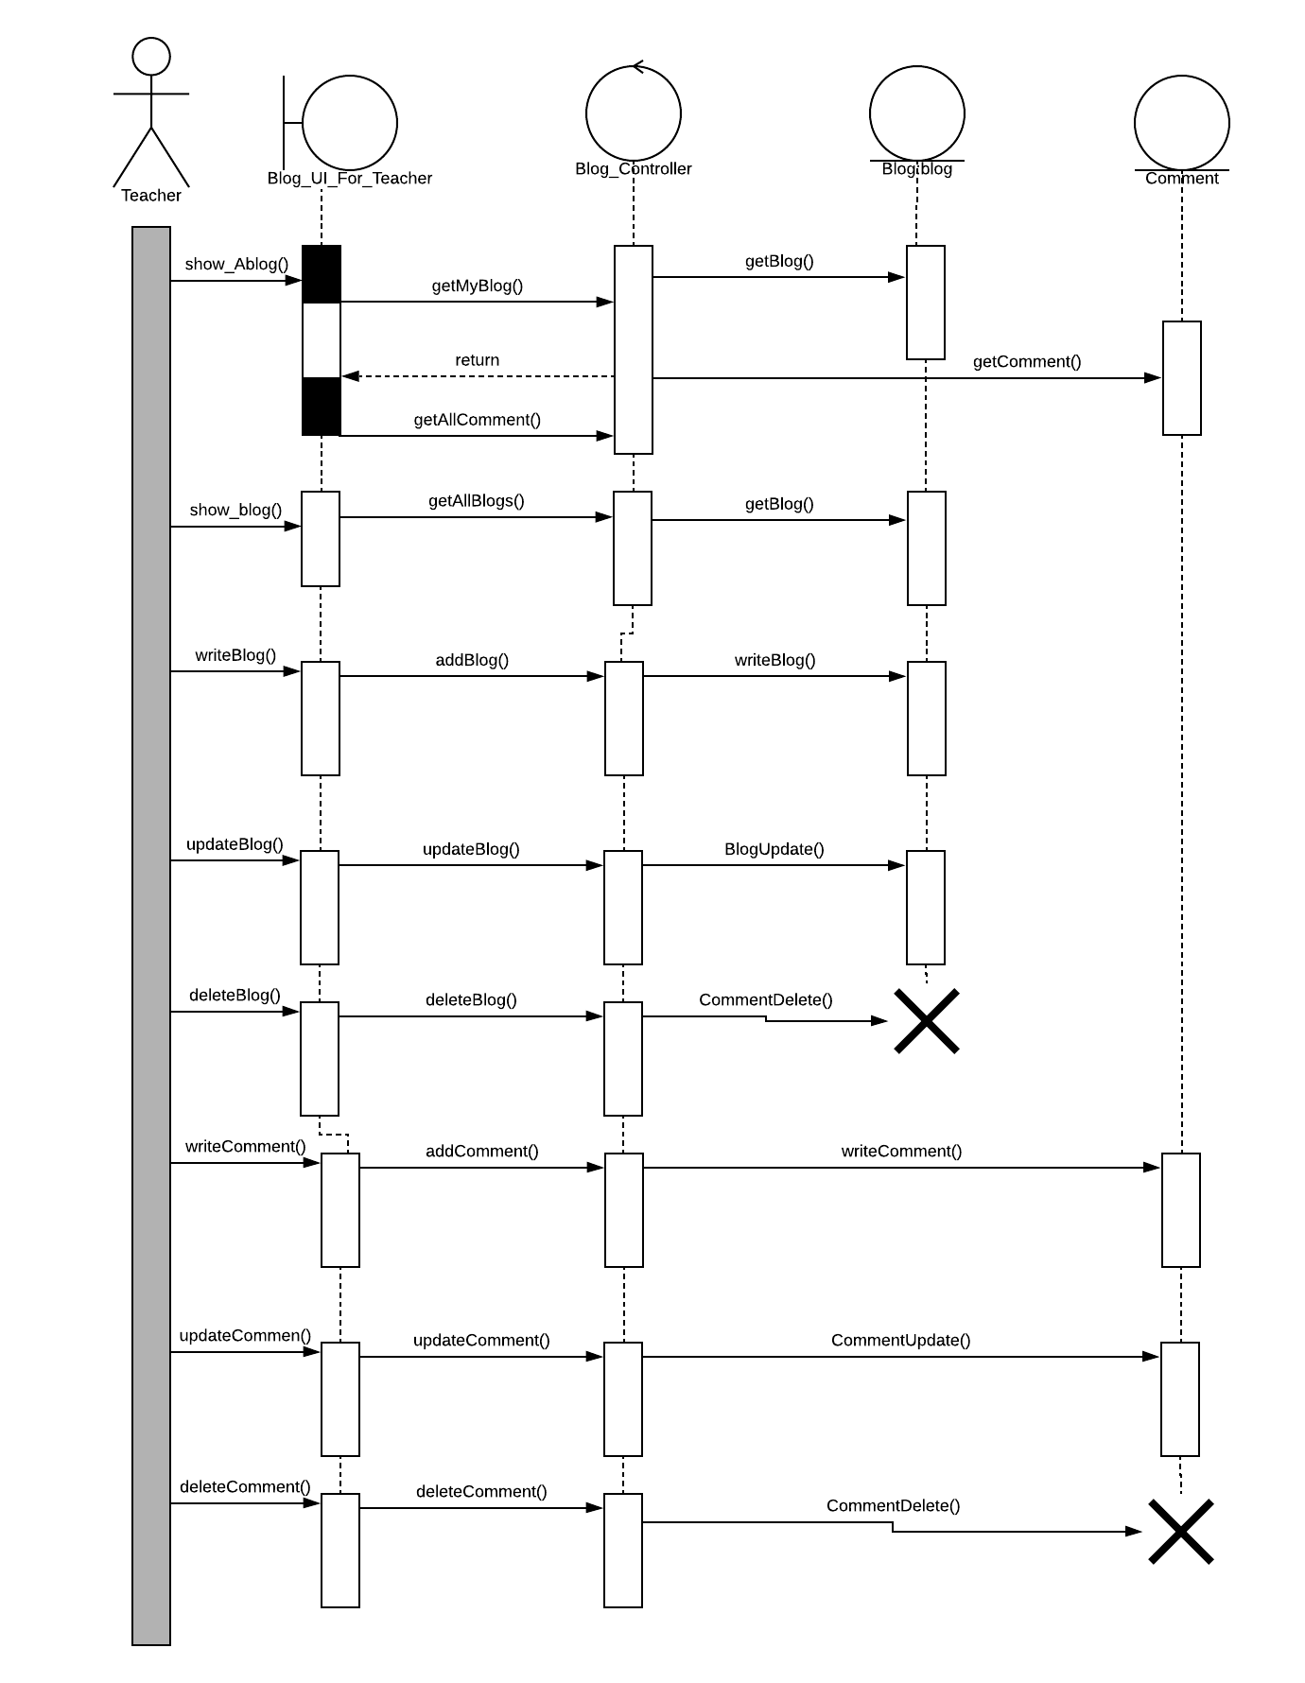

Figure: Sequence diagram for blog subsystem

## DATA FLOW DIAGRAM

We draw a data flow diagram for examination setup subsystem. Here is the data flow diagram:

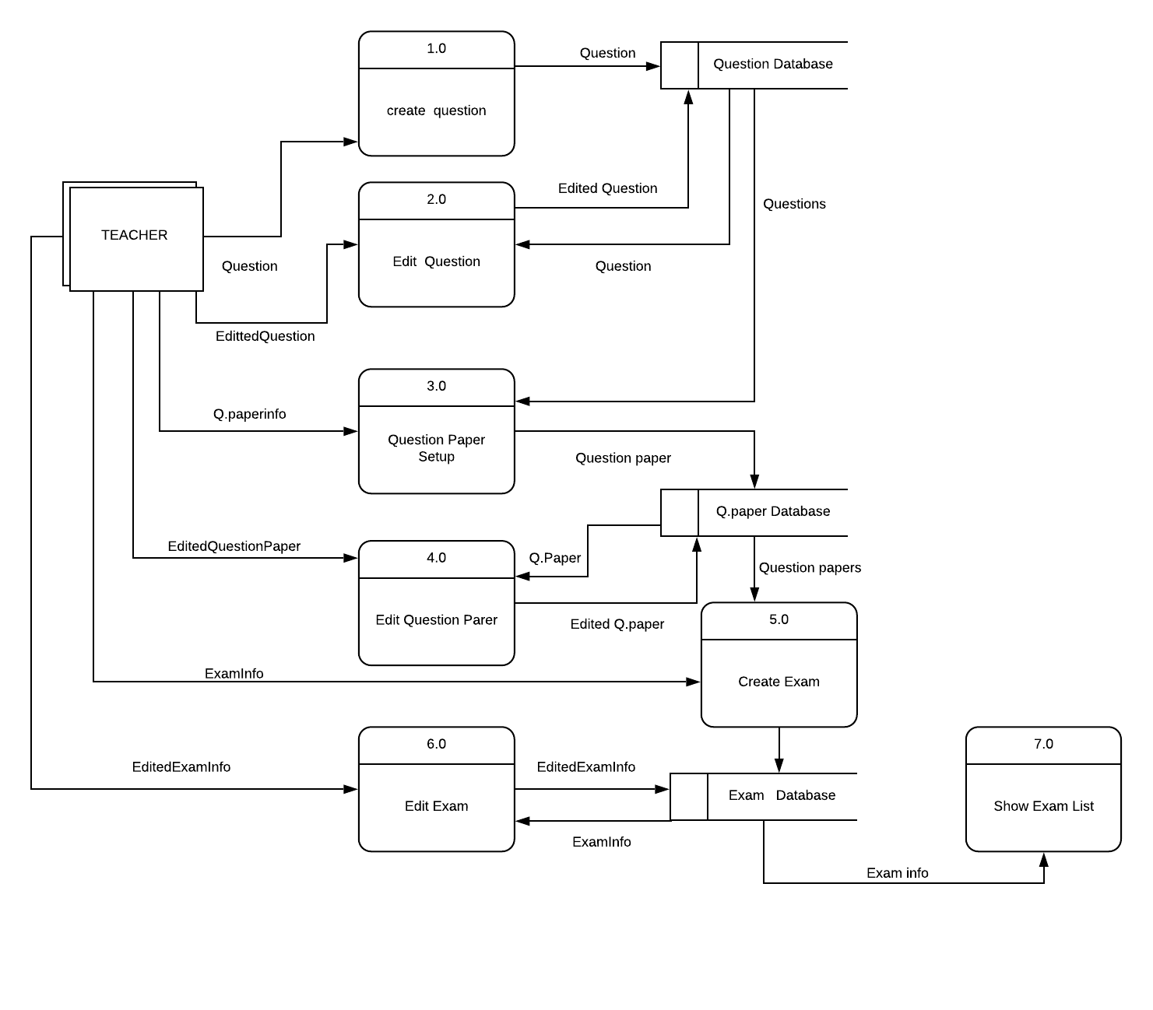

Figure: Data flow diagram

## GANTT CHART

We estimate our time cost for every activity. Here is the gantt chart:

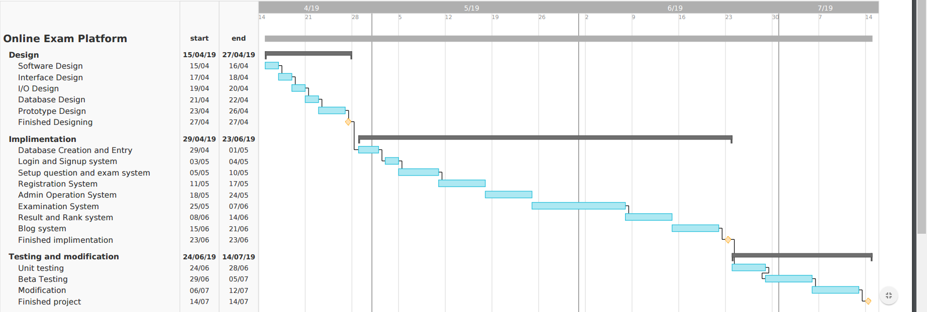

Figure: Gantt chart

## implimentation examples

We implemented blog subsystem and registration subsystem for teacher. We use Laravel framework which use MVC (Model View Controller) design pattern. In our implementation, a teacher can register and post blog which can be letter edited and deleted. Any other person can view the blog.

Here are some screen shots of our implementation:

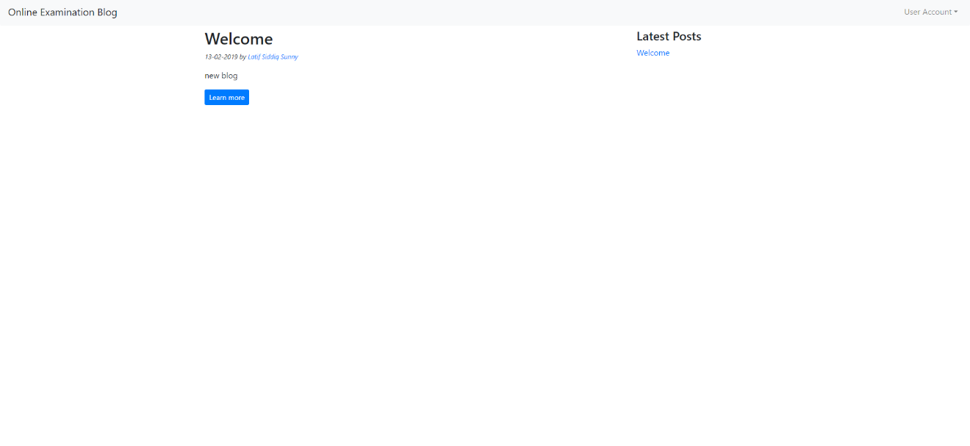

Figure: Home page

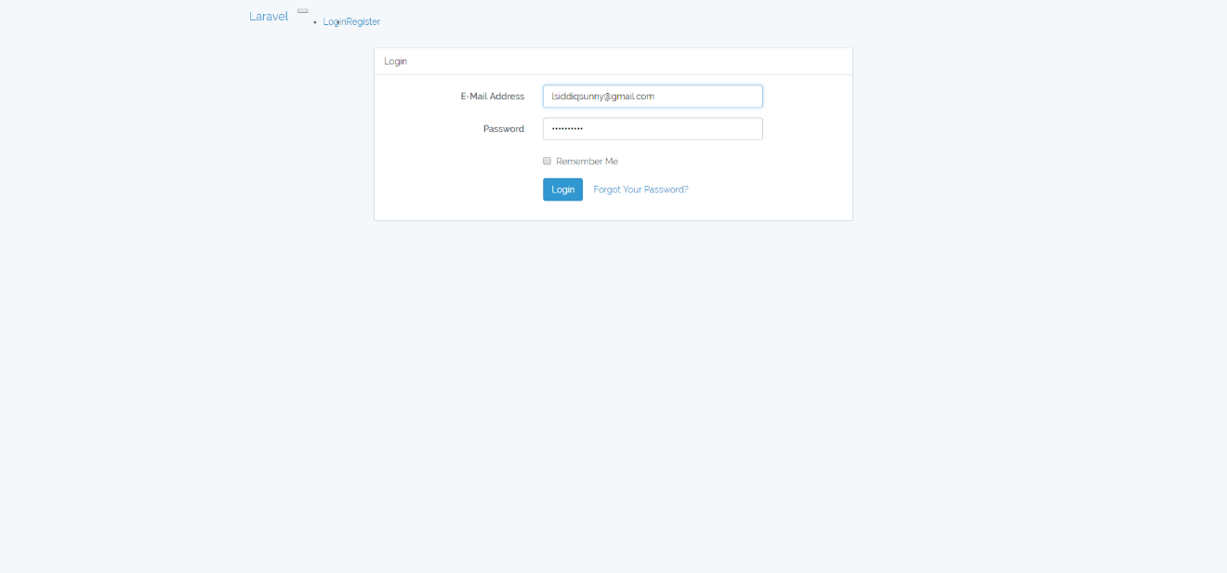

Figure: Login window

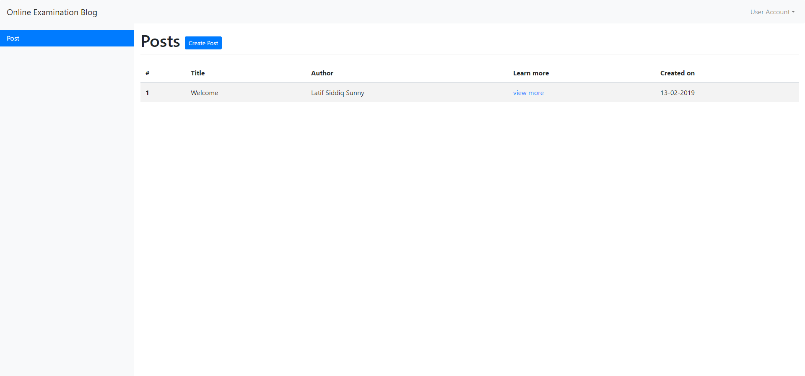

Figure: Dashboard for teacher

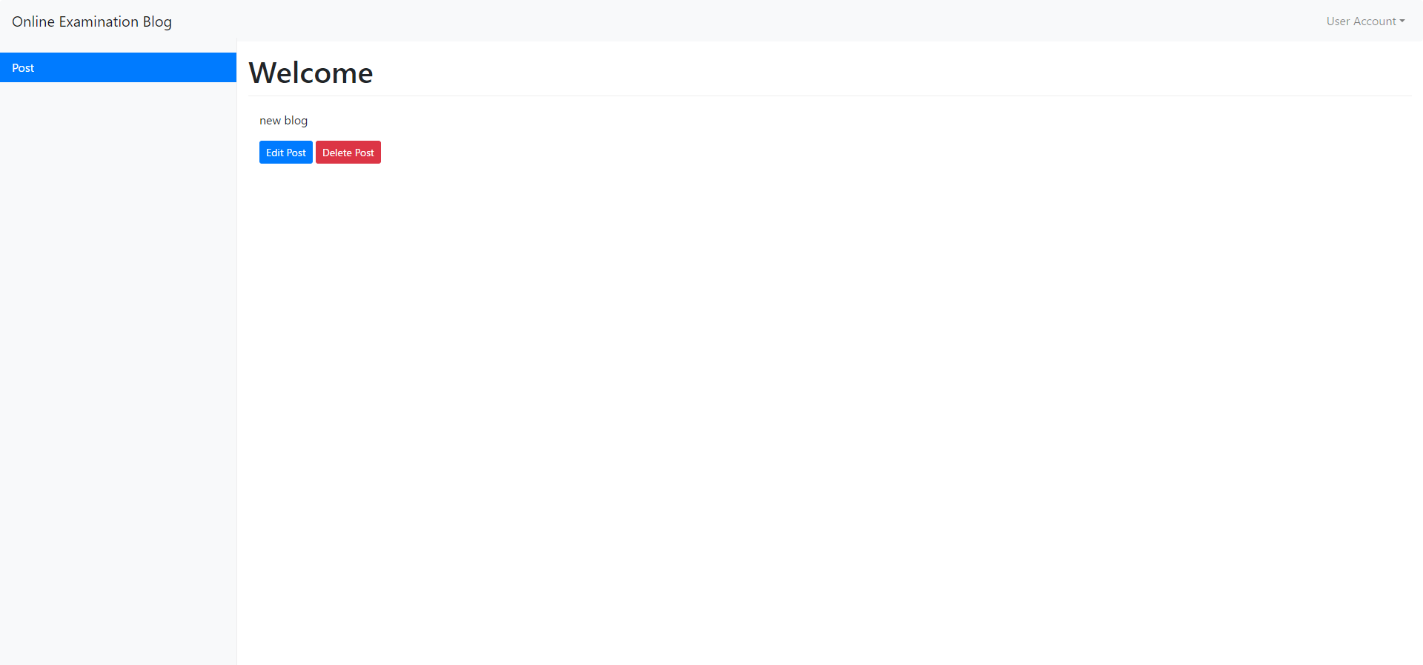

Figure: Blog can be edited and deleted by teacher

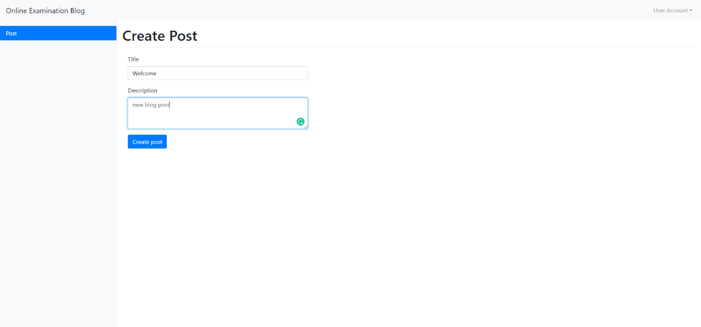

Figure: Blog creation window for teacher

## Conclusion Remarks

This project can be useful to the students from rural area. In the next term, we should try to complete the project and many students can get benefits from this projects.